# Apply filters to SQL queries

## Project description

[Describe what you accomplish through SQL.]

It was like you were making a sentence to command a computer or SQL to give you an output of what you were looking for such as AND OR LIKE and more.

## Retrieve after hours failed login attempts

Your team is investigating failed login attempts that were made after business hours. You want to retrieve this information from the login activity. You’ll identify all unsuccessful attempts after 18:00.

The login_time column in the log_in_attempts table contains information on when login attempts were made. Office hours end at '18:00'.

The success column in the log_in_attempts table contains values of TRUE or FALSE to indicate whether the login was successful. MySQL stores Boolean values as 1 for TRUE, and 0 for FALSE. This means that TRUE is represented as 1, and FALSE represented as 0 in the success column.

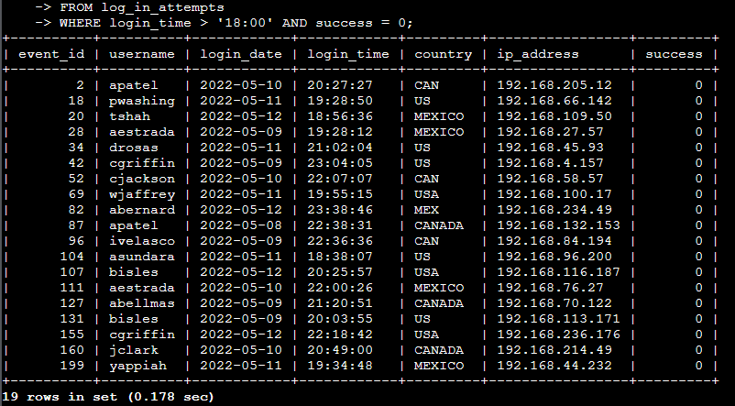

First i Select all then i find it from login attempts then i ask the computer where it should search and as you can see it outputs the employees under 18:00 of the login time.

## Retrieve login attempts on specific dates

Your team is investigating a suspicious event that occurred on '2022-05-09'. You want to retrieve all login attempts that occurred on this day and the day before ('2022-05-08').

The login_date column in the log_in_attempts table contains information on the dates when login attempts were made.

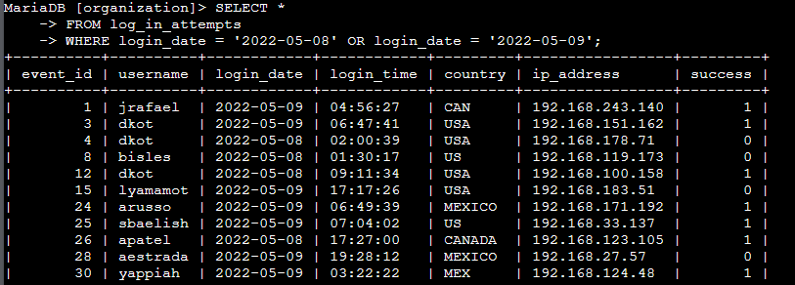

What I did here was select all and search from login attempts where login date should be on the day of 8 and 9 and the output was 75 login attempts in just two days.

## Retrieve login attempts outside of Mexico

Now, your team is investigating logins that did not originate in Mexico, and you need to find this information. Note that the country field includes entries with 'MEX' and 'MEXICO'. You should use the NOT and LIKE operators and the matching pattern 'MEX%'.

* Run the following SQL query to retrieve login attempts that did not originate in Mexico. Replace X with the correct operator and Y with the correct pattern to filter for the information you need:

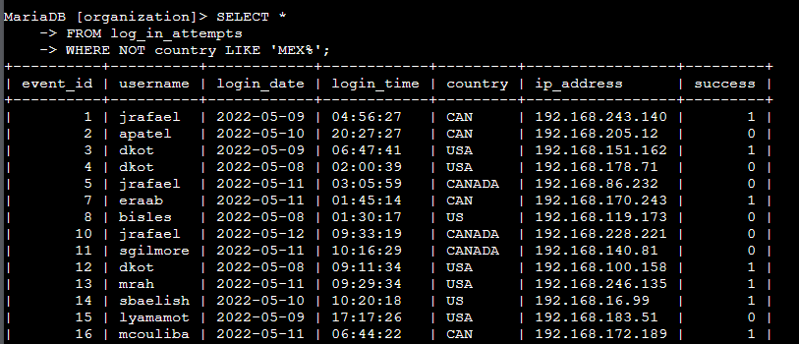

What i did here is i use the NOT and LIKE to see which country had login outside from MEXICO

## Retrieve employees in Marketing

Your team is updating employee machines, and you need to obtain the information about employees in the 'Marketing' department who are located in all offices in the East building (such as 'East-170' or 'East-320').

* Write a SQL query to retrieve this information from the employees table. Select all columns and include filters on the department and office columns to return only the needed records.

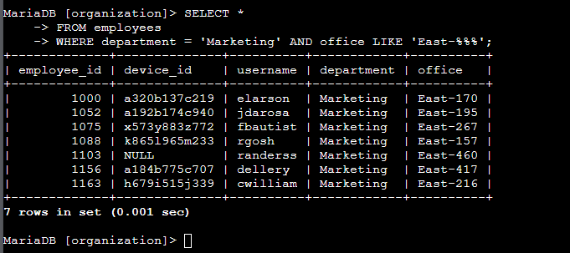

This one gives me a hard time to think I did several methods to make the east shown but it's not going through so what i did i use % to make the EAST-170 to EAST-320 shown.

## Retrieve employees in Finance or Sales

Now, your team needs to perform a different update to the computers of all employees in the Finance or the Sales department, and you need to locate information on these employees.

* Write a SQL query to retrieve records for employees in the 'Finance' or the 'Sales' department.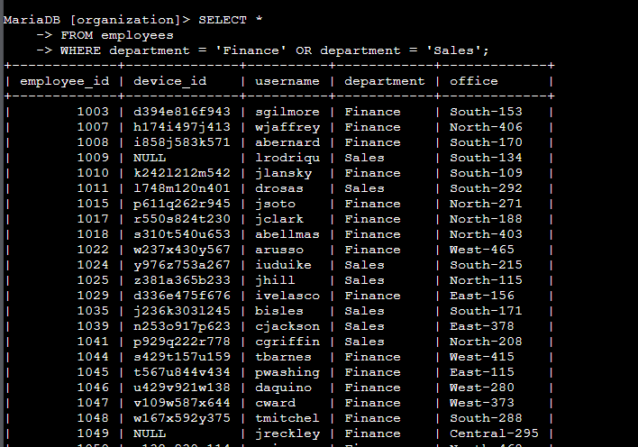

Here I find where the two departments are in just one command using OR command.

## Retrieve all employees not in IT

* Write a SQL query to retrieve records for employees who are not in the 'Information Technology' department.

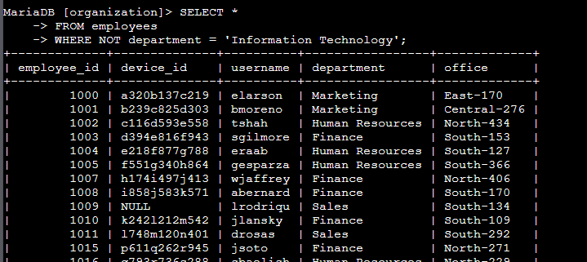

With using NOT command I exclude the information technology department from other departments.

## Summary

From what i learned about this course i got my hands on SQL using AND LIKE OR with the help of guidelines i know this was a practicing tool but in future i hope this helps me out with work that i got landed on.